Name – Kamal D. Agrahari Subject – DevOps Lab

ID -VU4F2223028 TE IT A | Batch B

**Experiment No. 4**

**Aim** - : To Install Jenkins on Windows.

**Theory** –

Jenkins:

Jenkins is a Java based open-source application, which is one of the most popular tools for continuous integration and continuous delivery on any platform.

Jenkins is a self-contained server that can be used to automate all sorts of tasks related to building, testing, and delivering or deploying software. It has many plugins for automating almost everything at the infrastructure level. The use of Jenkins has widely increased due to a rich set of functionalities, which it provides in the form of plugins.

The Jenkins project has two release lines: Stable (LTS) and regular (Weekly). Depending upon the scenario and need, one can be chosen:

* Stable (LTS): Long-Term Support (LTS) release baselines are chosen every 12 weeks from the stream of regular releases.
* Regular releases (Weekly): This delivers bug fixes and new features rapidly (generally weekly) to users and plugin developers who need them.

Jenkins can be installed through native system packages, Docker, or even run standalone by any machine with a Java Runtime Environment (JRE) installed.

Steps for Installing of Jenkins:

Step 1: Install JDK 17 or JDK 21 as they are supported Java versions for jenkins. After successful installation of JDK you will get the following respond in command prompt.

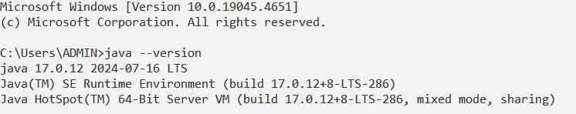

Step 2: Navigate to the “jenkins.io/download/” website and under Jenkins LTS system, click on Windows for the latest Jenkins package. This will download “jenkins.msi” installer.

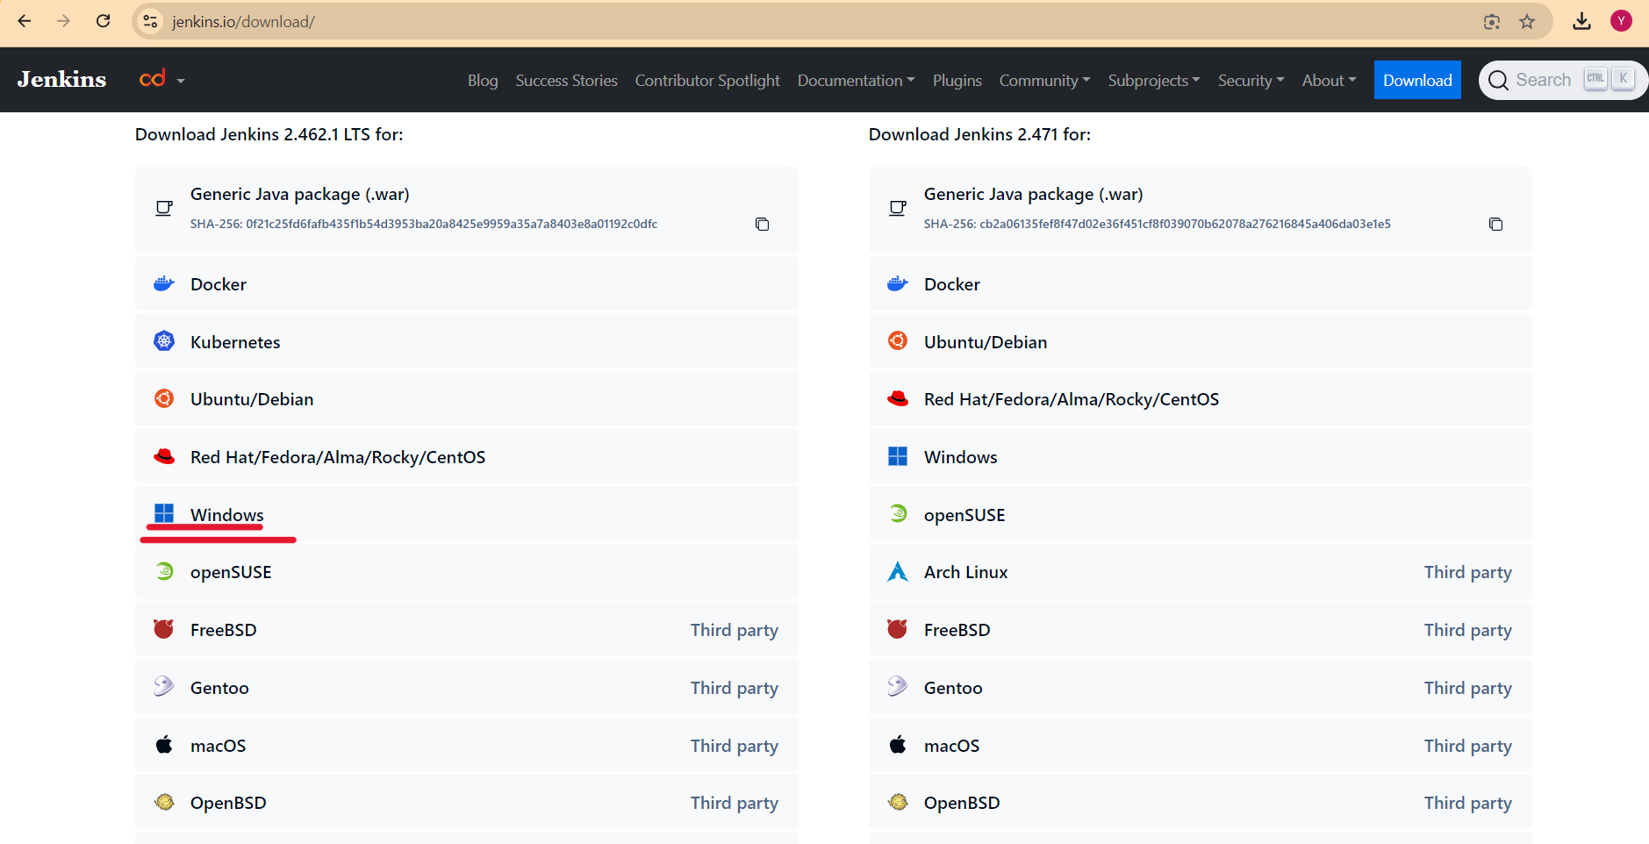

Step 3: Once the jenkins.msi is downloaded open it and proceed. Then choose the Jenkins Path. Give Logon type as “Run Service as Local System” and test the recommended port 8080 in next step and proceed the installation.

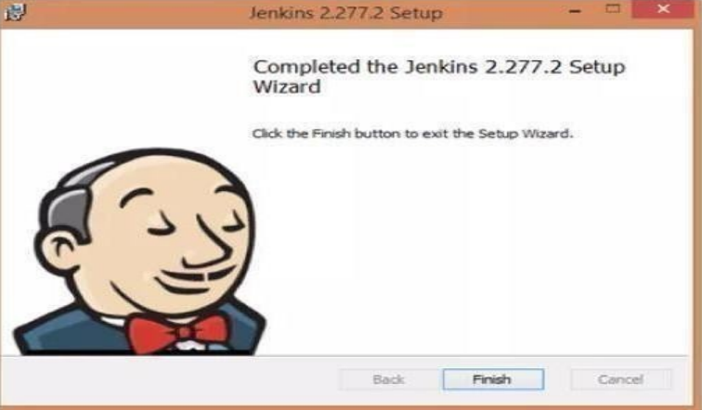

Step 4: You will be redirected to a local Jenkins page by default. If page is not loaded by default, paste the URL http://localhost:8080 , with the chosen port in the browser.

After completing the Jenkins installation phase, we will proceed with its configuration set up.



Step 5 : For Unlocking Jenkins, copy the password from the file at C:\Windows\System32\config\systemprofile\AppData\Local\Jenkins\.jenkins\secrets (shown on screen) and paste it in the Administrator password field. Click on Continue.

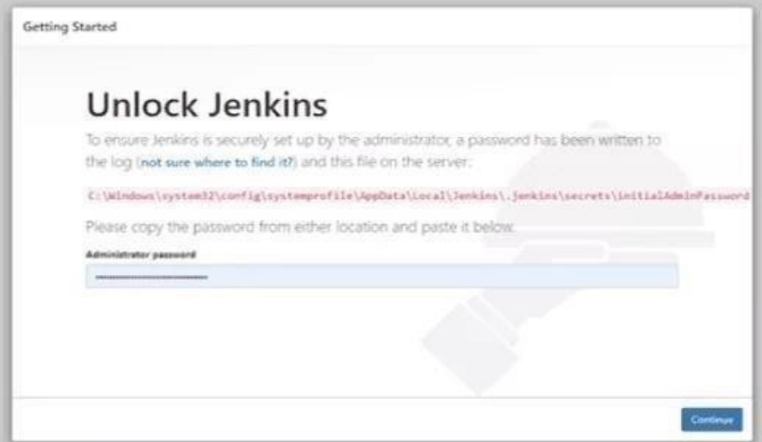

Step 6 : Choose "Install suggested plugins" and let the plugins install completely.

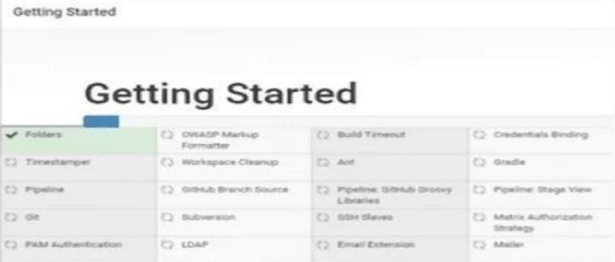

Step 7 : Finally the default Jenkins page will be shown as below.

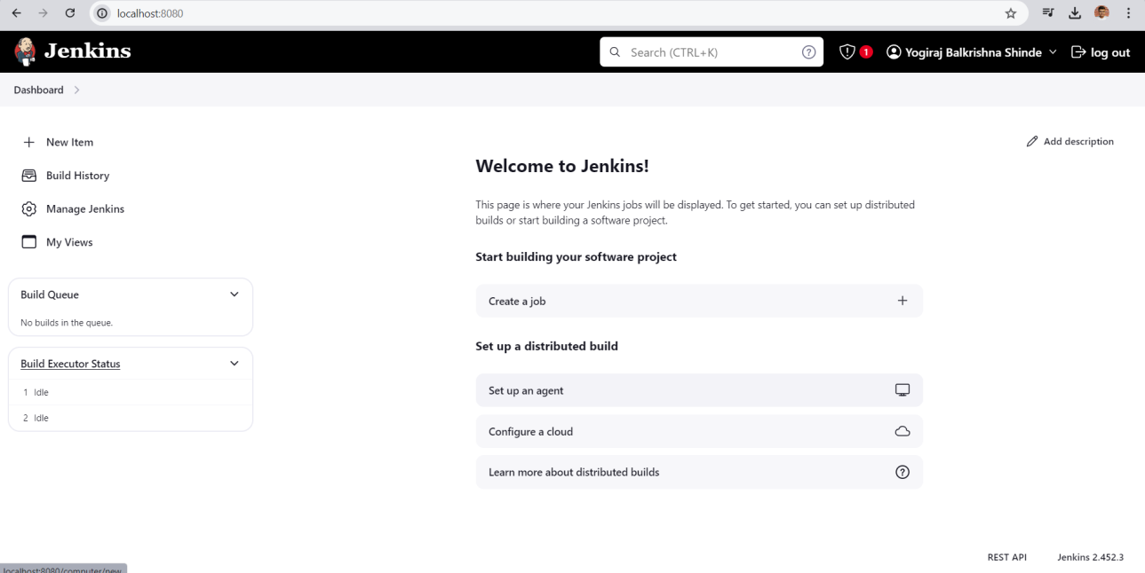

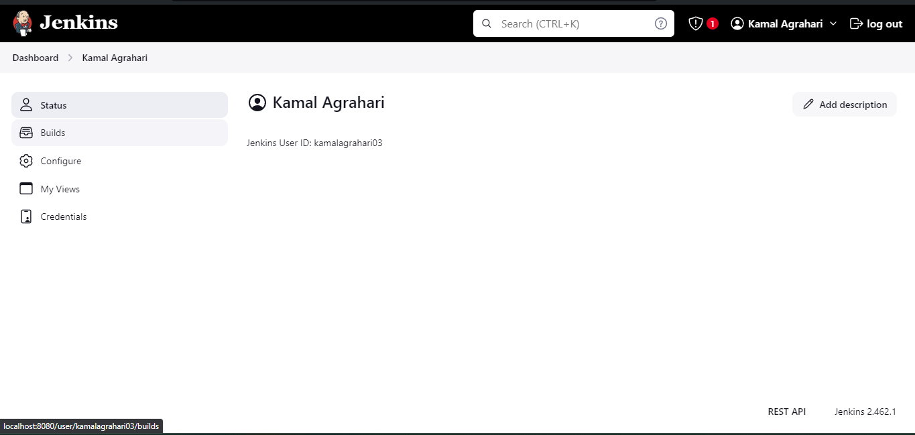

**Conclusion:**

Hence we have perform Installation of Jenkins on Windows.